Goto Environmental variable for Axis(make sure you placed axis2 folder under C drive)

Create new System variable

AXIS_HOME

C:\SOAPUI\axis2-1.6.2\axis2-1.6.2

Under System variable

Path folder

Create New or add the below

C:\SOAPUI\axis2-1.6.2\axis2-1.6.2\bin

Make sure

JAVA_HOME available with jdk or jre.

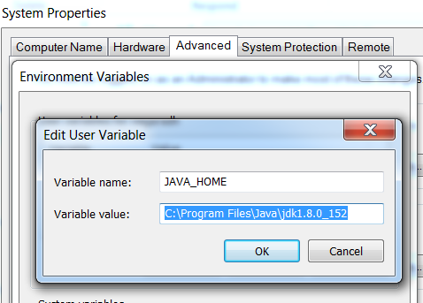

**JAVA-HOME – under User variables**

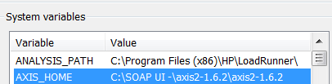

**AXIS_HOME – under system variables**

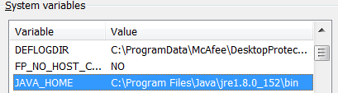

**JAVA – HOME System variables**